(Approx. 460 words)

What Happened to Word’s Overtype Mode?
By Nancy DeMarte, 2nd Vice President, Sarasota Technology Users Group, FL
February 2017 issue, Sarasota Monitor
www.thestug.org
ndemarte (at) verizon.net

If you used versions of Word before 2007, you probably encountered an editing feature called Overtype mode. This feature was introduced to save time when you needed to change some text in a document. To turn on Overtype mode, you pressed the Insert key on the keyboard. With Overtype enabled, every character you typed replaced the one to its right. It eliminated the step of deleting a group of text and inserting new text in its place.
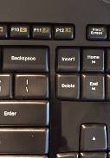
If you were an Overtype user, you might have wondered why it doesn’t work anymore. Beginning with Word 2007, Overtype mode has been disabled. Why? One reason is that it was hard for the user to tell if Overdrive were enabled. With no light or indicator on the screen, you didn’t know whether Overdrive was active or not until you began typing. Non-professional typists like me would occasionally press the Insert key by accident, engaging Overtype and find ourselves deleting text we wanted to keep. Figure 1 shows how close the Insert key is to the common Backspace and Delete keys.

Figure 1 – Insert key

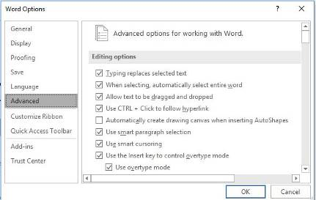
Although Overtype mode is disabled in recent versions, you can make it accessible using one these two methods. First, with a Word document open, click File, then Options. (In Word 2007, click the Office button, then Word Options.) Then click Advanced from the left menu, and under Editing Options, click the checkbox which says, “Use Overtype mode.”( Figure 2) If you want the Insert key to control whether Overtype is on or off, click the checkbox next to “Use the Insert key to control Overtype mode.” Then click OK.
Figure 2 - Overtype settings in Word Options

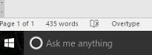
An easier way to enable Overtype and know whether it is on or off is to add it to the Status bar. This bar runs along the bottom of every Word Window above the Taskbar (That’s the one with the Zoom slider on its right end.) Right click in an empty space on the Status bar. The list which appears shows you the tools you can add to this bar, one of which is Overtype. When you click it, the word Overtype appears near the left end of the status bar, showing that it is enabled. To disable it, click the word again and it becomes Insert. You don’t need to change the checkboxes in Word Options, and you don’t have to touch the Insert key. Just a glance at the status bar will tell you what editing mode you’re using, Insert or Overtype.
Figure 3 - Overtype on the status bar in Windows 10

